UK Local government structure and elections

Structure
The structure of local government varies from area to area. In most of England, there are 2 tiers – county and district – with responsibility for council services split between them.
London, other metropolitan areas and parts of shire England operate under a single tier structure with councils responsible for all services in their area.
In total there are 343 local authorities in England made up of 5 different types:
- county councils
- district councils
- unitary authorities
- metropolitan districts
- London boroughs
The table below shows the number of each type of council.
2 tier
County councils | 26
District councils | 192
Single tier
Unitary authorities | 55
Metropolitan districts | 36
London boroughs | 32
City of London | 1
Isles of Scilly | 1
Total | 343
Some shire district councils (including unitary authorities) and all metropolitan district councils have the status of either a borough or a city and are referred to as borough or city councils.

Council map
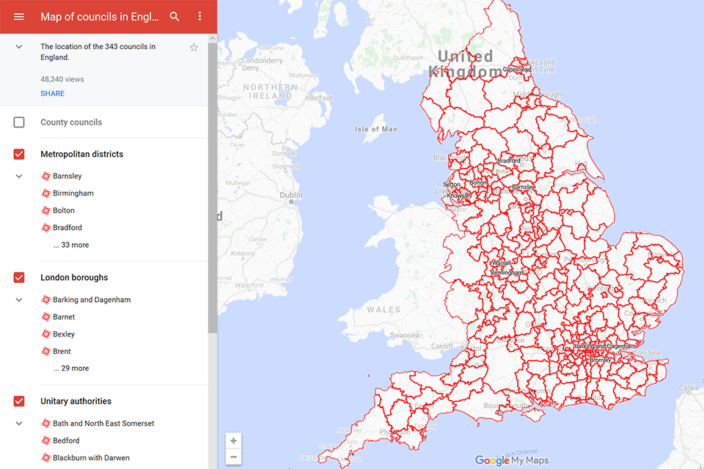

Unitary authorities
There are 55 unitary authorities. They provide all local government services in their areas. These are mainly in the cities, urban areas and larger towns although there are now 6 shire county councils that are unitary (ie have no district councils beneath them).

London boroughs
There are 32 London boroughs. They provide nearly all the services in their area. However, the Greater London Authority (GLA) provides London-wide government, including special responsibility for police, fire, strategic planning and transport.

Metropolitan districts
There are 36 metropolitan district councils which together cover 6 large urban areas: the counties of Greater Manchester, Merseyside, South Yorkshire, Tyne and Wear, West Midlands, and West Yorkshire.
Metropolitan districts are responsible for all services in their area, although certain conurbation wide services such as fire and civil defence, police, waste disposal and passenger transport are provided through joint authorities (the districts acting jointly).

County councils
There are 26 county councils in 2-tier areas, providing services such as education, social services and waste disposal.

District councils
In 2-tier areas, each county council area is subdivided into districts, for which there is an independent district council. There are 192 district councils.
District councils are responsible for local services such as rubbish collection, housing and planning applications.

City of London
The City of London Corporation provides local government and other services for the ‘Square Mile’. These include economic development, education, environmental health, highways management, housing, libraries, the Barbican Arts Centre, policing, social services, waste collection and town planning.

Isles of Scilly
The Council of the Isles of Scilly is a unitary authority, but with some local government services being provided in conjunction with Cornwall Council. It also has its own water authority, airport authority and other powers, including running its own Sea Fisheries Committee.

Town and parish councils
There are also approximately 9,000 town or parish councils in England. These operate at a level below district councils and unitary authorities.
Because of their great diversity, parishes do not generally have statutory functions, although they are often responsible for smaller local services such as allotments, parks and community centres. They may provide other services with the agreement of the county or district council.
The Local Government Act 2000 sets out the governance models that must be operated by local authorities. These are:
- a mayor and cabinet executive
- a leader and cabinet executive
- the committee system
- or other arrangements approved by the Secretary of State
Local people can have a say on the governance model adopted by their local authority via a referendum in certain circumstances.
Number of councillors
The number of councillors for each local authority is decided by the independent Local Government Boundary Commission for England.
It is responsible for electoral arrangements (the reviewing and implementing of the number and boundaries of electoral areas and the number of councillors) in local authorities in England.
The Secretary of State for Communities and Local Government has no role.
Visit the Local Government Boundary Commission website for more information.

Local councils and elections
Members of councils - councillors - are elected for 4-year terms using the first past the post system.

When elections are held
Elections to councils are held on the first Thursday in May.

Electoral cycles
There are a variety of electoral cycles (times when elections are held) so not all councillors are elected at the same time.
The 3 methods of holding elections to local councils are:
- by whole council (all of the councillors are elected every 4 years)
- by halves (half of the councillors are elected every 2 years)
- by thirds (a third of the councillors are elected every year for 3 years, with no elections in the 4th year)

Electoral areas
In county councils (including single tier county councils) councillors represent electoral areas called divisions.
In other types of council these areas are called wards.
An electoral area (ward or division) may be represented by 1, 2 or 3 councillors.
In county councils there is usually 1 councillor for each electoral area.
Metropolitan districts elect 3 councillors and wards in shire district, unitary authorities and London boroughs elect between 1 and 3 councillors.

Examples
Where a district council holds whole-council elections all councillors are elected at the same time. For example electors in a 2-member ward cast 2 votes each and elect 2 councillors at the same time.
Where a district council holds elections by thirds, a third of the councillors for the whole council will be elected at each annual election. Electors in a 3-member ward will vote in each of the elections, electors in a 2-member ward will vote in 2 out of 3 and electors in a single-member ward will vote in 1 of the 3 elections.

